Unveiling The Virtual Classroom: An In-Depth Analysis Of The Online Education System

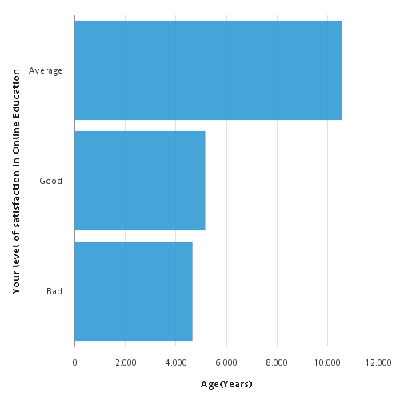Age Vs Level of satisfaction in online education

Aug 5, 2023 1 4:16:21 AM

